Types of Network Traffic
# Source: AI Source: Provided by: [Data Path: Persons Table -> ID Column: 1, Name_En Column: Motasem Essam] -> From: [ChatGPT] on [12/9/2025]
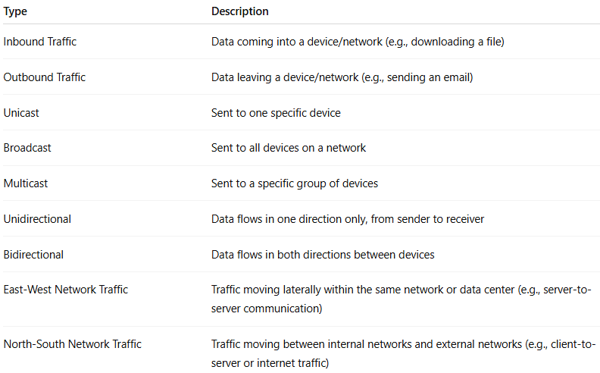
Type | Description
Inbound Traffic | Data coming into a device/network (e.g., downloading a file)
Outbound Traffic | Data leaving a device/network (e.g., sending an email)
Unicast | Sent to one specific device
Broadcast | Sent to all devices on a network
Multicast | Sent to a specific group of devices
Unidirectional | Data flows in one direction only, from sender to receiver
Bidirectional | Data flows in both directions between devices
East-West Network Traffic | Traffic moving laterally within the same network or data center (e.g., server-to-server communication)
North-South Network Traffic | Traffic moving between internal networks and external networks (e.g., client-to-server or internet traffic)

